**Lab 6: NPN Common Emitter Amplifier (3% of total)**

**Objective:**

To build and test an NPN-based common-emitter (CE) amplifier to amplify small AC signals.

**Equipment and Components:**

* Breadboard, Power supply, Digital Multimeter, Function generator, Oscilloscope
* NPN transistor (2N2222)
* Resistors (10kΩ, 20kΩ, 80kΩ, others per design)
* 3 Capacitors (47 *μ*F)

**Background:**

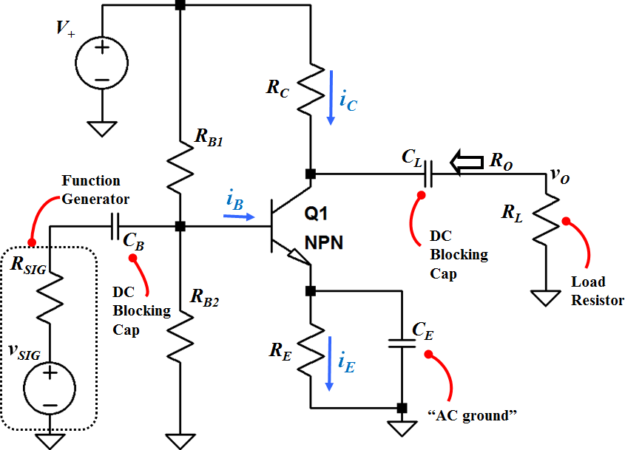

**Fig. 1 NPN Common-Emitter amplifier circuit with coupling capacitors**

Fig. 1 shows an NPN Common-Emitter (Emitter is common between Base and Collector) amplifier circuit. Note that ***vSIG*** and ***RSIG*** represent the ac signal source and its internal resistance, respectively. For the calculation and simulation purposes, include ***RSIG***; however, omit it in the actual circuit on the breadboard.

Also, note that for simulation, we will use 2N2222 but in the actual circuit it may change.

Coupling capacitors ***CB*** and ***CL*** block DC voltages. Here ***CB*** blocks DC voltage, which is used to bias the base, from entering the ac signal source. ***CL*** blocks DC voltage, which is to bias the collector, from appearing at the load. Ideally, if a small ac signal is applied at the base, we should obtain an ac signal at the collector with some amplification.

**Preliminary:**

*Design/ Calculate: (*Use Example 5.10 as a guide, but note that we don’t have the feedback RG)

Design the amplifier circuit to achieve a small-signal gain of at least ***AV*** = -200 V/V and ***IC*** = 1 mA. Use ***VCC***=15 V, ***RSIG*** = 50 Ω, ***RL*** = 10 kΩ, ***RB1*** =80 kΩ***,*** and ***RG2*** = 20 kΩ.

**Part 1:** **DC Analysis**

1. Sketch the DC model of the circuit in your lab book.

***Note:*** Replace the capacitors with open circuit.

1. Calculate ***IB***  and ***IE***. What is the value of ***VB*** ?
2. Determine the value of ***RE*** that produces *v***BE** = 0.7 V. What is ***VE***?

Note: At this stage, we know neither ***VCE*** nor ***RC***.

**Part 2:** **AC (small-signal) Analysis**

1. Sketch small-signal model of the circuit in your lab book.

***Note:*** Replace the transistor with its small-signal model, capacitors with short circuits, and *V+* with an AC ground. Assume VA is large, and ignore *rO*. What would happen to *RE*?

1. Label the base of the transistor as *vi*, i.e. the small-signal voltage at the input. What are the values of ***gm*** and ***rπ*** ?
2. Find the ratio, ***vi /vSIG*** .
3. Derive the expression for *AV = vo /vi* . What is the value of *RC* that produces a small-signal gain of at least *AV = - 200 V/V* ? What would be the overall gain *GV*?
4. What is the DC voltage at the collector, *VC*? What region is the transistor operating in?
5. What is the output resistance, *Ro*?

*Simulate:*

1. Using the values found above, and ***CG*** = ***CL*** = ***CS*** = 47 *μ*F, simulate the circuit.
2. Set the input *vsig* to 10mVpp, 1kHz with no DC component.
3. Record the DC values: *VBE, VCE*, *IB, IC* and *IE*.
4. Determine *Av and GV*.

**Procedure:**

***Note:*** You may need to adjust values of the components as necessary in the actual circuit in order to meet the design specifications, ***AVmin* = -200 V/V**. Also, you should not include ***RSIG***because it represents the internal resistance of the function generator.

1. Assemble the circuit using values from pre-lab.
2. Measure the DC voltages at the base (*V****B****),* emitter *(VE)*, and collector (*VC)*.
3. Apply an input ***vSIG*** of 10 mVpp at 1 kHz.

***Note:*** If 10mV is not available, use the smallest amplitude possible, but expect some distortion in the output waveform.

1. Generate the plots for *v0* and *vi* vs. time.
2. Measure all the resistors to three significant digits.
3. Calculate *VBE, VCE*, *IB, IC* and *IE* based on the above measurements.
4. What is the measured value of *Av and GV* ?
5. Increase the input voltage amplitude until you start seeing distortion in the output voltage. What is the maximum gain that you can achieve without distorting the output signal?

**Conclusion:**

1. Summarize the calculated, simulated, and measured results in a tabular form. The table should include the following parameters: *VBE, VCE*, *IB, IC*, *IE, Av and Gv*. Explain any discrepancies.

*Get your summary table checked off by the instructor.*